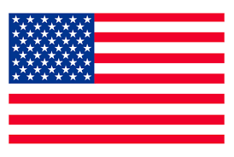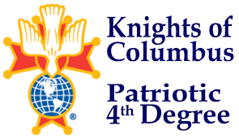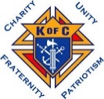

**CHARITY, UNITY, FRATERNITY DEGREE**

**4TH DEGREE EXEMPLIFICATION**

**MARCH 30, 2025**

**HOSTED BY**

RT. REV. MSGR. ROBERT P. BURNS - ASSEMBLY 606

**ADDRESS**

Knights Hall

105 Elm Ave.

Norfolk, Nebraska

**“Schedule of Events”**

11:30 AM - Doors open

12:00-12:20 PM - Charity, Unity, Fraternity Candidate Registration

12:30-1:05 PM - Charity, Unity, Fraternity Degree

Break

1:00-1:15 PM - 4th Degree Exemplification Candidate Registration

1:15-1:25 PM - Candidates Briefing

1:30-2:50 PM - Exemplification

3:00 PM - Photos

**Candidate Attire**

- Black or dark (blue or gray) business suit, w/white shirt, dark tie, black socks, and shoes.

- Active Duty Armed Forces, law enforcement, and fire fighters may wear their Class A/ Service Dress.

- Priests may wear clerical attire.

**- If attire is a concern, please contact the District Master to discuss options.**

**Notes:**

- If possible, proposer should be at the Charity, Unity, Fraternity Degree and/or Exemplification.

- Please review and ensure Forms are completed, especially FN, FC, FS, and Proposer signatures.

- Council Financial Secretary please fill out Exemplification Form 4 and sign member is in good standing.

- Fee for Exemplification candidate is $70.00, please make checks payable to: Nebraska District Master.

- No fee for Priest, Deacons, or Seminarians.

- Exemplification ceremony is for Sir Knights, candidates, family, and friends may attend.

- If possible, RSVP by noon on Friday March 28, 2025, w/ Exemplification candidate’s name to Host SK Randall Pinkelman.

**Questions can be directed to the host Assembly 606**

**Faithful Navigator: SK Randall Pinkelman**

**402-750-9204 or email: rpinkelman@conpoint.com**

**SK Dan Svitak**

**402-750-8532**

**or**

**Nebraska District Master: SK Mark Borytsky, PSD**

**402-212-9612**

