
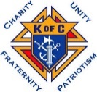
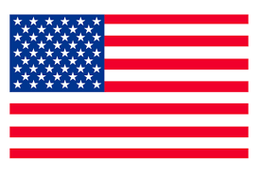
CHARITY, UNITY, FRATERNITY DEGREE
and
4TH DEGREE EXEMPLIFICATION
MARCH 22, 2026

HOSTED BY: CARDINAL FRANCIS SPELLMAN - Assembly 3486

ADDRESS
St. Matthew Catholic Church
(west side basement entrance)
12330 S. 36th St.
Bellevue, NE

“Schedule of Events”
12:00-12:35 PM - Charity, Unity, Fraternity Degree
12:35-1:10 PM - Lunch and 4th Degree Exemplification Candidate Registration
1:10-1:20 PM - Candidates Briefing
1:30-2:45 PM - 4th Degree Exemplification

“Please note wives, family, and friends are cordially invited to attend the degrees”
Candidate Attire:
- Business suit/Blazer with slacks (if you do not have a suit or blazer, button up shirt/polo with slacks is acceptable)
- Active Duty Armed Forces, Law Enforcement, and Fire Fighters may wear their Class A/ Service Dress.
- Priests may wear clerical attire. Seminarians may wear appropriate attire.
- If attire is a concern, please contact the District Master to discuss options.

Notes:
- If possible, proposer should be at the Charity, Unity, Fraternity Degree and/or Exemplification.
- Please review and ensure Forms are completed, especially FN, FC, and Proposer signatures.
- Council Financial Secretary please fill out Exemplification Form 4 portion and sign member is in good standing.
- Fee for Exemplification candidate is $70.00, please make checks payable to: Nebraska District Master.
- No fee for Priest, Deacons, or Seminarians.

Questions can be directed to the host Assembly 3486
Faithful Navigator: SK Dick Harrington
402-516-6152 or email: richardft@aol.com
or
Nebraska District Master: SK Mark Borytsky, PSD
402-212-9612 or email: mborytsky@cox.net

