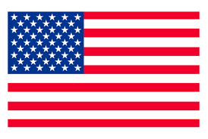
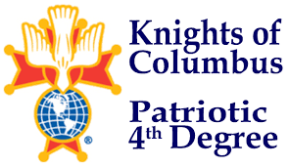
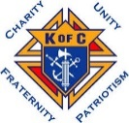
CHARITY, UNITY, FRATERNITY DEGREE
4TH DEGREE EXEMPLIFICATION
July 18, 2026

HOSTED BY:
“Assembly 601”

ADDRESS
St. Mary’s Cathedral Square
112 S Cedar St.
Grand Island, Nebraska

“Schedule of Events”
11:00 - 11:35 AM - Charity, Unity, Fraternity Degree.
11:45 AM - 12:45 PM - Lite Lunch & 4th Degree Candidates Registration. 12:45 - 12:55 PM - 4th Degree Candidates Briefing.
1:00 - 2:30 PM - 4th Degree Exemplification.
2:30 - 2:45 PM - Photos.

“Please note wives, family, and friends are cordially invited to attend the degrees”
Candidate Attire:
- Business suit/Blazer with slacks (if you do not have a suit or blazer, button up shirt/polo with slacks is acceptable)
- Active Duty Armed Forces, Law Enforcement, and Fire Fighters may wear their Class A/ Service Dress.
- Priests may wear clerical attire. Seminarians may wear appropriate attire.
- If attire is a concern, please contact the District Master to discuss options.
Notes:
- If possible, proposer should be at the Exemplification.
- Please review and ensure Forms are completed, especially FN, FC, and Proposer signatures.
- Council Financial Secretary please fill out Exemplification Form 4 portion and sign member is in good standing.
- Fee for Exemplification candidate is $70.00, please make checks payable to: Nebraska District Master.
- No fee for Priest, Deacons, or Seminarians.

Questions can be directed to the host Assembly 601
Former Faithful Navigator: SK Doug Glunz
Email: djglunz59@gmail.com
308-379-8969
or
Nebraska District Master: SK Mark Borytsky, PSD
402-212-9612 or email: mborytsky@cox.net

