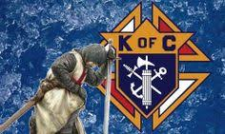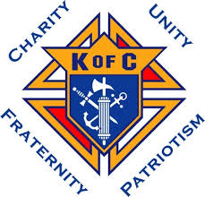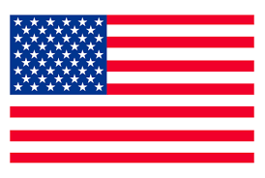

**4th DEGREE**

**EXEMPLIFICATION**

**November 24, 2024**

**HOSTED BY**

Bishop James V. Casey, Assembly 599

**ADDRESS**

St. Joseph Catholic Church (Basement)

1415 California St.

Superior, NE 68978

**“Schedule of Events”**

1:30 - 2:00 PM - Registration

2:00 PM - Mass

2:30 PM - Candidate briefing

2:45 - 4:15 PM - Exemplification

4:15 PM - Assembly photos w/ social following

(Free will offering)

**Candidate Attire:** (If attire is a concern, please contact the District Master to discuss options)

Black or dark (blue or gray) business suit, w/white shirt, dark tie, black socks, and shoes.

Active Duty Armed Forces, law enforcement, and fire fighters may wear their Class A/ Service Dress.

Priests may wear clerical attire.

**Good To Know:**

If possible, proposer should be at the Exemplification.

Please review and ensure Form 4 is completed, especially FN, FC, FS, and Proposer signatures.

Council Financial Secretary please fill out Form 4 and sign member is in good standing.

Fee for candidates is $70.00, please make checks payable to: Nebraska District Master.

No fee for Priest, Deacons, or Seminarians.

Exemplification ceremony is for Sir Knights and candidates; families may attend after for photos and social.

**Questions can be directed to the host Assembly 599**

**Faithful Navigator or Faithful Comptroller**

**SK Robert Unruh, robertelee785@gmail.com**

**SK David Wiedel, 402-768-3579 or email:** [**dnbwiedel@windstream.net**](mailto:dnbwiedel@windstream.net)

**or**

**Nebraska District Master**

**SK Mark Borytsky, PSD**

**402-212-9612**